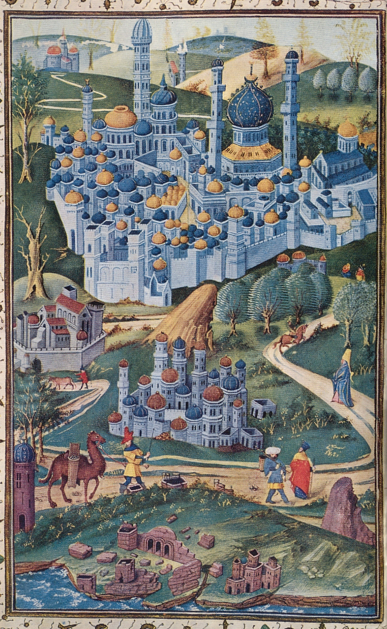
Causes mentioned by historians: Accumulation of other possibilities for European travellers

Before the sixteenth century, pilgrimage to the Holy Land was one of the most common ways for Europeans to travel. In the ‘Age of Discovery’ Europeans found new destinations, America for instance. From that time on the Holy Land had to share its position on the list of possible destinations with many other destinations.

F. Thomas Noonan, The Road to Jerusalem: Pilgrimage and Travel in the Age of Discovery (Philadephia: University of Pennsylvania Press, 2007), 13.

