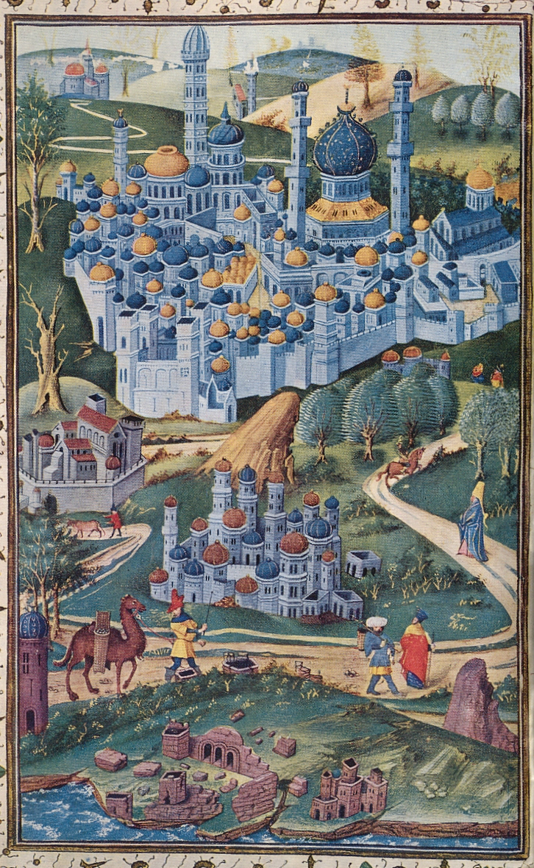
Causes mentioned by historians: Increase of short distance pilgrimage

At the end of the Middle Ages a lot of the smaller places of pilgrimages also offered to provide their visitors with indulgences. It is possible that the amount of pilgrims crossing long distances diminished in light of this fact. Nevertheless, this argument is not easy to verify because the small places of pilgrimage have not kept records about the amount of visitors. Furthermore, the importance of indulgences for pilgrims should not be exaggerated.

