Causes mentioned by historians: Interiorisation of belief

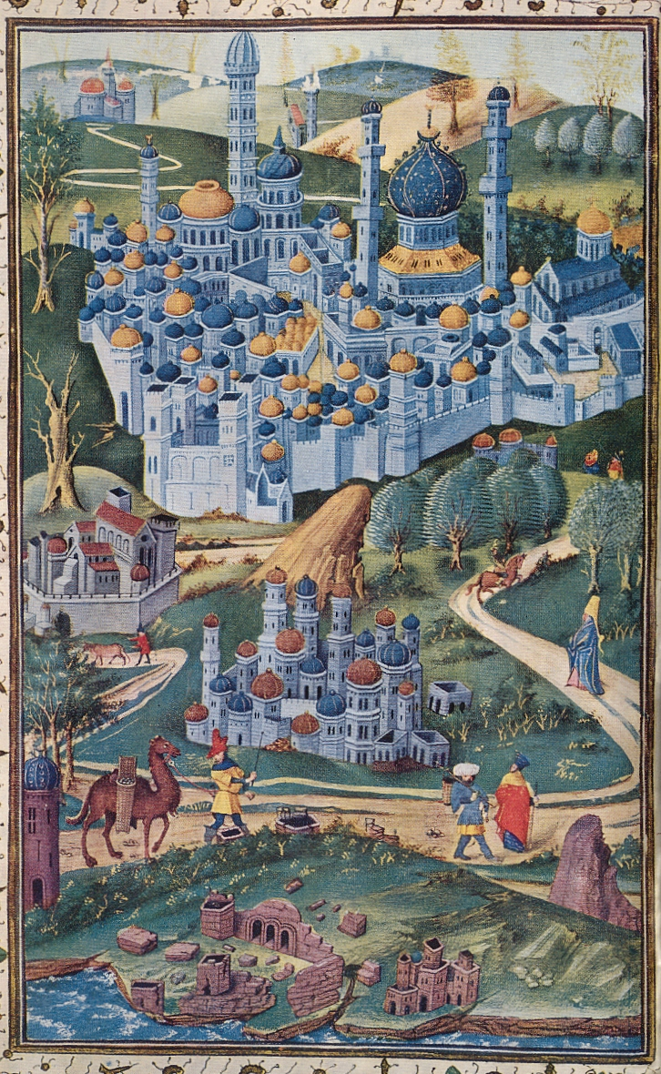
According to Donald Howard, who was specialized in Medieval literature, the decline of pilgrimage in the fifteenth and sixteenth centuries was not at all caused by Protestantism, but by the Catholic faith itself: religion was turning inward and was less and less concerned with ‘physical things – relics, costumes, travel’.

Donald R. Howard, Writers and Pilgrims: Medieval Pilgrimage Narratives and Their Posterity (Berkely, Los Angeles & Londen: University of California Press, 1980), 105.

