Causes mentioned by historians: Loss of interest of the nobility

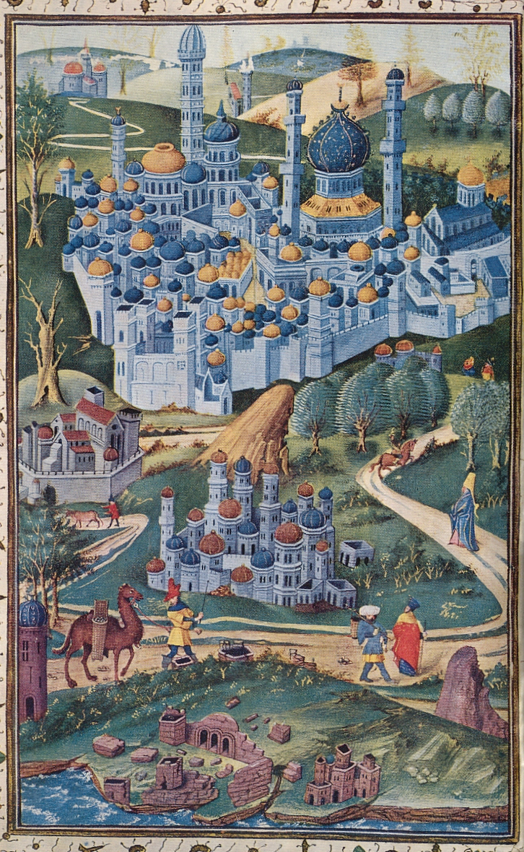
Greffin Affagart, a French nobleman who went on pilgrimage in 1533, declared that the passage to the Holy Land formerly was facilitated by the nobility who paid for the ships. In his era however, the nobility seemed to have lost interest in the Holy Land. Pilgrims had to find their own way to the Holy Land as the network built around the passage, primarily supported by ‘lords and princes’, seems to have collapsed at the time of Affagart’s pilgrimage.

Colin Morris, The Sepulchre of Christ and the Medieval West: From the Beginning to 1600 (Oxford: Oxford University Press, 2005), 363.

