Causes in Felix Fabri’s Evagatorium: Ottoman presence in the Mediterranean

At the moment Fabri’s ship was about to set sail, news came of the Ottoman siege of Rhodes (23 Mai until 28 July 1480). In every town where he went ashore, the citizens discouraged him and the others to proceed with their pilgrimage. A citizen of Ragusa (modern Dubrovnik, Croatia) told him: ‘We fear him [the Turk] all the same, and are fortifying ourselves against him; for though he be our friend to-day, he will be our foe to-morrow.’ The Ottomans’ victory over the Western Christians could easily have been a reason why people were not attracted to the Holy Land in the fifteenth and sixteenth centuries. Nevertheless network analysis helps to reduce the strength of this argument. Fabri’s account is also full of examples of the ongoing connections in the Mediterranean. For instance, Fabri mentions Germans in Methoni (Messenia, Greece), Ottoman merchants in Heraklion (Crete, Greece) who recommended Fabri and the others not to go to the Holy Land and two Venetian vessels of which the passengers spread the news about the Ottomans. This means that networks still functioned even when the Mediterranean had become a dangerous place. This has to do with the degree of centralization of the network in the Mediterranean. As this degree was low (most people did not know each other, they just ran in to each other once) the network had a bigger chance to survive.
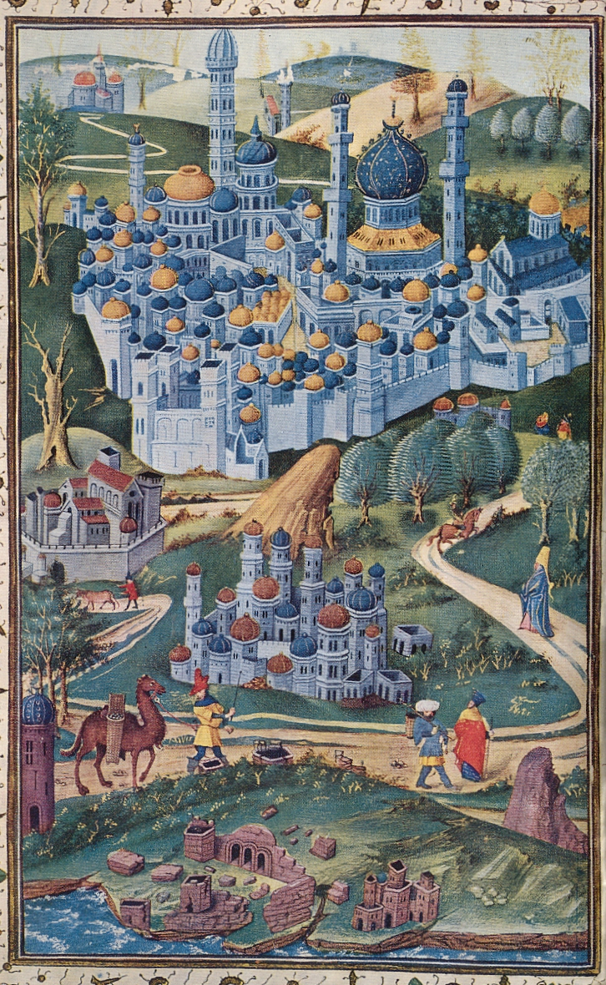

Felix Fabri, The Book of the Wanderings of Brother Felix Fabri, vert. Aubrey Stewart vol. 1 (Londen: Palestine Pilgrim’s Text Society, 1896), 16.

