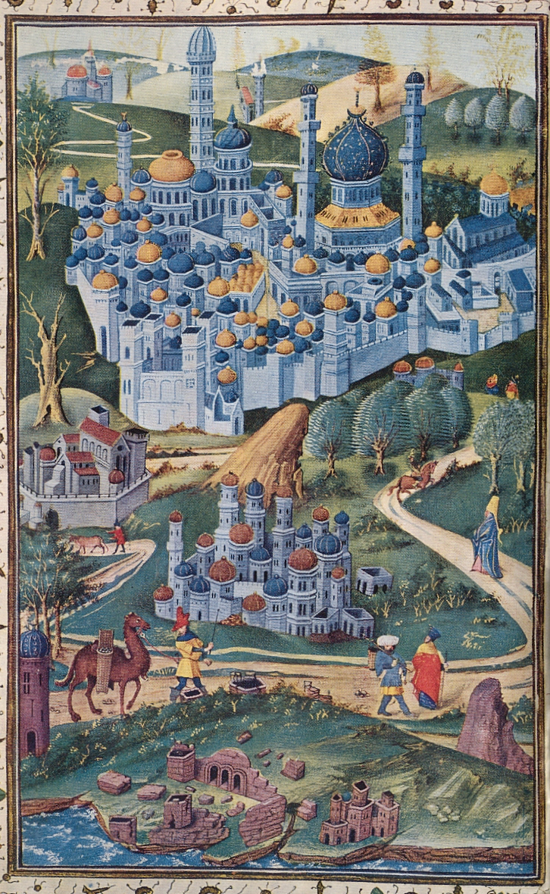
Causes in Felix Fabri’s Evagatorium: Pilgrimage narratives themselves

Maybe the answer to my research question lies not only in the things Fabri mentions, but in the fact that he mentions those things and in the way in which he informs us. At first I tried to ignore the dramatic character of the narrative of Fabri’s pilgrimage, but now I have come to think that the account in itself – emphasizing in an extremely dramatic way all the potential dangers and difficulties encountered on the way to Jerusalem – could be considered as a means by which pilgrims were discouraged to choose the Holy Land as their destination. Fabri virtually closes his first pilgrimage account by writing ‘By this all men may see clearly how untrue is the common saying, that the pilgrimage by sea from Venice to the Holy Land is a mere pleasant excursion with little or no danger.’ Network analysis could be useful for future research in reconstructing the audience of pilgrimage narratives. By determining who might have been influenced by these narratives, we could get a clue as to the importance of these narratives in the decline of pilgrimage at the end of the Middle Ages.

Felix Fabri, The Book of the Wanderings of Brother Felix Fabri, vert. Aubrey Stewart vol. 1 (Londen: Palestine Pilgrim’s Text Society, 1896), 47.

