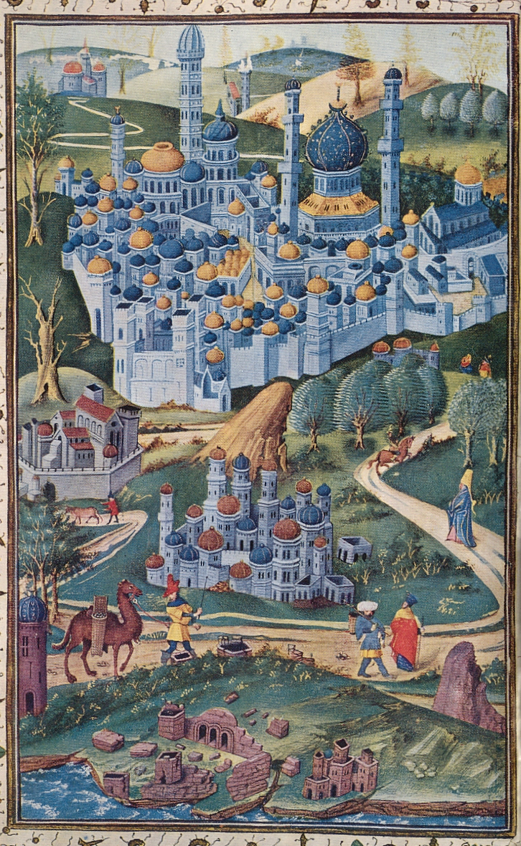
Causes mentioned by historians: Plague
In difficult times people were more inclined to undertake a pilgrimage. The plague, for example, was seen as a divine punishment for human sins. People departed for the Holy Land to do penance.

