Causes in Felix Fabri’s Evagatorium: Preparatory networks

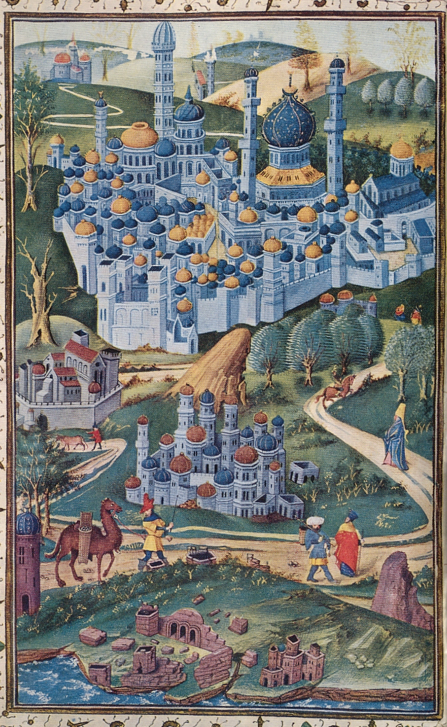
To undertake a pilgrimage one first and foremost needs to be able to leave home. For Fabri this meant he needed consent of the pope and of the Master of the Order of the Preachers. Through an acquaintance, Sigismond Heyligraber, a Dominican in Rome, he was able to get the documents he needed. Heyligraber functioned as a broker here. Secondly, one needs capital to finance a pilgrimage. Fabri, being a clergy and of noble birth, very easily got the financial support he needed from lord Apollinaris von Stein. For people in the lower echelons of society, it would have been difficult to get funding for a pilgrimage as they were not connected to networks of patrons and nobles. If we take Greffin Affagart’s argument that nobility was losing interest in the Holy Land, to be true, this means that even the people connected to the noble networks would have a hard time getting their pilgrimage financed in the sixteenth century. This accounts for a decline of pilgrimage.

