Causes mentioned by historians: Protestantism
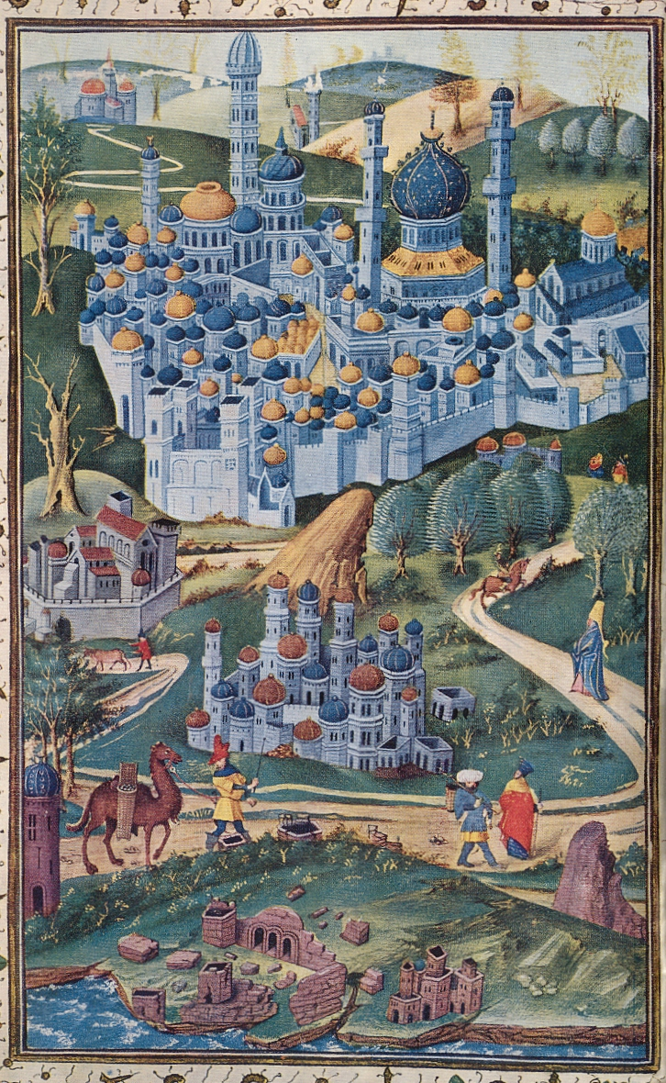
Most historians blame the Protestant Reformation for the decline. First the Lollards, an English movement that arose in the thirteenth century and tried to reform Christianity, and after that the Protestants ruthlessly criticized the practice of pilgrimage. In their view, it was a distraction of the pure and real belief, and they considered it idolatry. However, as Diana Webb, former Lecturer in History at Kings College London, puts it, ‘[c]riticism does not of itself, however, prove that the practice being criticised is losing popularity: it may even suggest the opposite.’ Sean Eric Clark, student at the University of Arizona, has written a dissertation on Protestant pilgrims. He concludes that Protestants used to distinguish pilgrimage to the Holy Land from pilgrimage in general. While they attacked the general concept, they went on pilgrimage to Jerusalem themselves.

Diana Webb, Medieval European Pilgrimage, c.700-c.1500 (Basingstoke: Palgrave, 2002), 42.

