Causes mentioned by historians: Unfavourable policy of the Ottomans towards the Christian holy sites

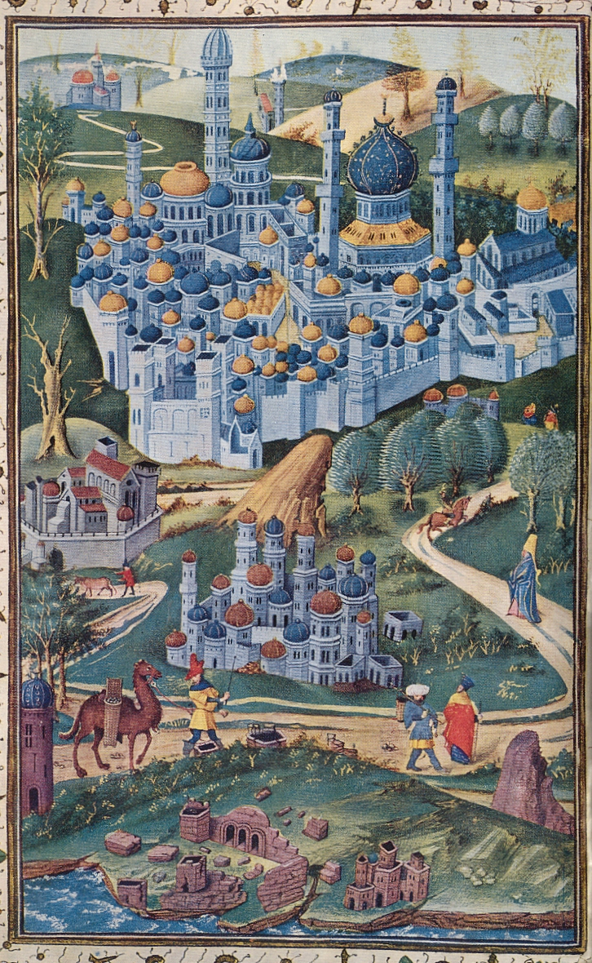
The Ottoman sultan Suleiman the Magnificent (1494-1566) had the ambition to turn Jerusalem into an Islamic holy place. The Ottomans denied Christians the access to a number of holy sites and the Franciscans of Mount Sion lost their operating base in 1551. This argument is actually not this strong since the Franciscans found shelter closer to the Holy Sepulchre and they maintained some control of the holy sites.

