Causes mentioned by historians: Waning naval power of the Venetians and increasing power of the Ottomans
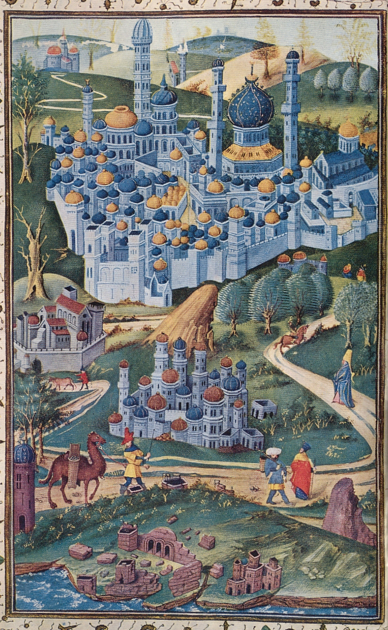
Because of the Ottoman conquest of Rhodes in 1522 and Cyprus in 1571 the Venetians were on the verge of losing their naval empire. This should have affected the mercantile networks stretching the Eastern Mediterranean and also the possibilities of passage for the pilgrims bound for the Holy Land.

